The Learning Problem HW1

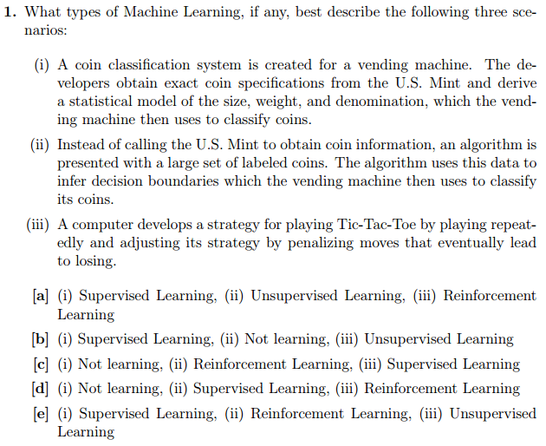

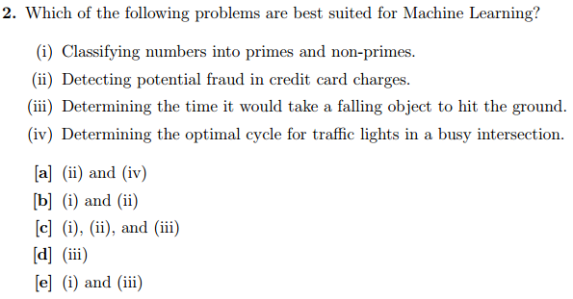

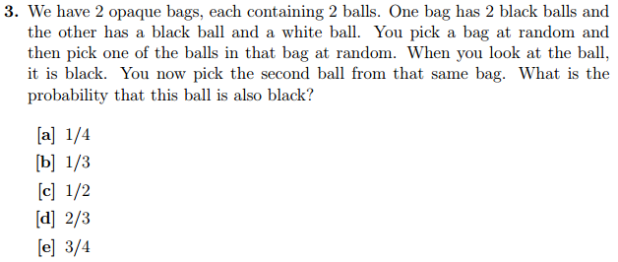

$B_{1}$ is the bin with 2 black balls. $B_{2}$ is the bin with a black and a white ball. $P\left(BlackBall\right)$ Is the probability of drawing a black ball from picking a bag at random then picking a ball at random. $P\left(BlackBall-1\right)$ is the probability of drawing a blackball at random from a bag chosen at random given that that bag already has had a black ball removed from it.

$$P\left(BlackBall | B_{1}\right)=1$$

$$P\left(BlackBall | B_{2}\right)=0.5$$

$P\left(BlackBall\right)=P\left(BlackBall | B_{1}\right)*P\left(B_{1}\right)+P\left(BlackBall | B_{2}\right)*P\left(B_{2}\right)=1*0.5+0.5*0.5=0.75$ (total probability law)

$$P\left(B_{1} | BlackBall\right)=P\left(BlackBall|B_{1}\right)*\frac{P\left(B_{1}\right)}{P\left(BlackBall\right)}=1*\frac{0.5}{0.75}=\frac{2}{3}$$

$$P\left(B_{2} | BlackBall\right)=P\left(BlackBall|B_{2}\right)*\frac{P\left(B_{2}\right)}{P\left(BlackBall\right)}=0.5*\frac{0.5}{0.75}=\frac{1}{3}$$

$$P\left(WhiteBall\right)=1-P\left(BlackBall\right)=1-0.75=0.25$$

$$P\left(WhiteBall | BlackBall\right)=P\left(WhiteBall | BlackBall, B_{1}\right)*P\left(B_{1}|BlackBall\right)+P\left(WhiteBall | BlackBall, B_{2}\right)*P\left(B_{2}|BlackBall\right)=0*\frac{2}{3}+1*\frac{1}{3}=\frac{1}{3}$$

Correction:

$$P\left(BlackBall | BlackBall\right)=1-P\left(WhiteBall | BlackBall\right)=1-\frac{1}{3}=\frac{2}{3}$$

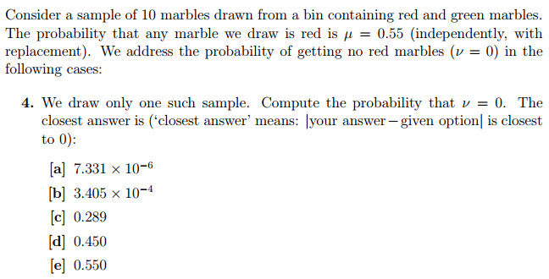

$S$ is the randomly drawn sample from the bin. $m_{red}$ is a red marble.

$$ν=0↔m_{red}∉S$$

$$P\left(ν=0\right)=P\left(m_{red}∉S\right)={\left(1-P\left(m_{green}\right)\right)}^{10}={\left(1-0.55\right)}^{10}={0.45}^{10}=3.405E^{-4}$$

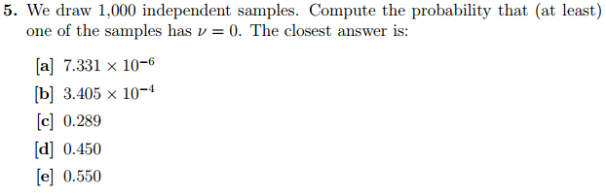

$i$ indexes all thousand independent samples $S_{i}$ independently and randomly drawn from the bin. The problem of having at least 1 of the 1000 samples be all $m_{red}$ can be approximated with a binomial distribution. $k$ is the number of successes (all of a sample $S_{i}$ is $m_{red}$), $n$ is the number of trials (1000), $p$ is the probability $P$ (all of a sample $S_{i}$ is $m_{red})$.

$$P\left(∃i s.t. ν_{i}=0\right)=1-P\left(∀i, v_{i}≠0\right)=1-{\left(3.405E^{-4}\right)}^{0}*{\left(1-3.405E^{-4}\right)}^{1000}=1-0.71137=0.2886$$

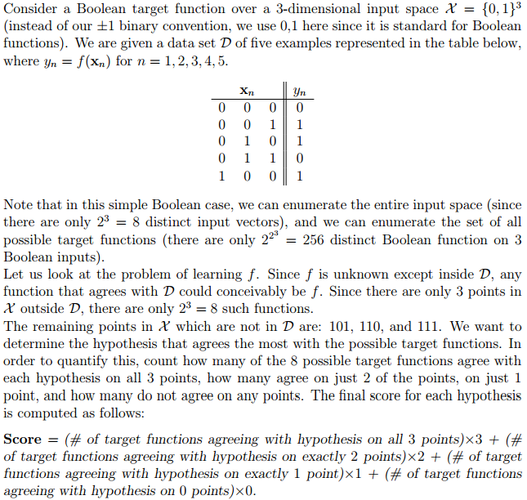

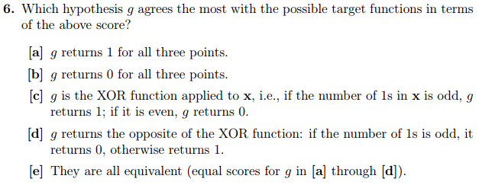

Each possible target function is denoted as $h_{i}$

|  |  |  |  |
| --- | --- | --- | --- |
| Hypothesis | 101 | 110 | 111 |
| $$h_{1}$$ | 0 | 0 | 0 |
| $$h_{2}$$ | 0 | 0 | 1 |
| $$h_{3}$$ | 0 | 1 | 0 |
| $$h_{4}$$ | 1 | 0 | 0 |
| $$h_{5}$$ | 1 | 1 | 0 |
| $$h_{6}$$ | 0 | 1 | 1 |
| $$h_{7}$$ | 1 | 0 | 1 |
| $$h_{8}$$ | 1 | 1 | 1 |

|  |  |
| --- | --- |
| Hypothesis | Score |
| $$g=1$$ | $$1*3+3*2+3*1+1*0=12$$ |
| $$g=0$$ | $$1*3+3*2+3*1+1*0=12$$ |
| $$g=XOR$$ | $$1*3+3*2+3*1+1*0=12$$ |
| $$g=!XOR$$ | $$1*3+3*2+3*1+1*0=12$$ |

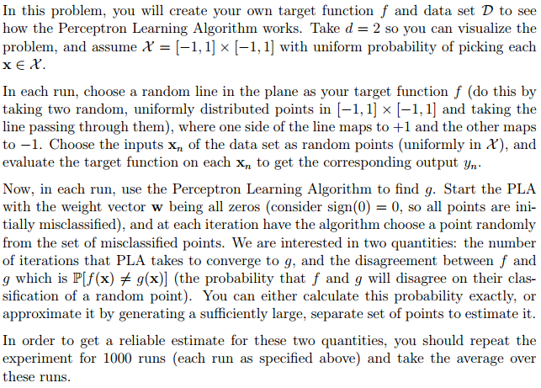

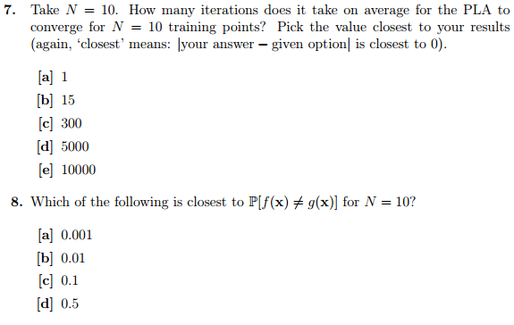

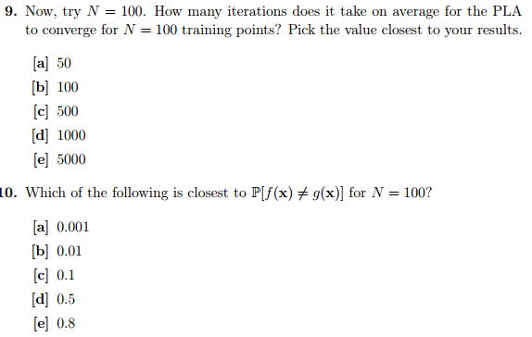

Refer to PLA Implementation on github.com/cmishra/PLA-Implementation for how I found the above (10 and 8 were calculated approximately).

Grade:

Incorrect answers:

* #3 (I accidentally found $P(WhiteBall|BlackBall)$ instead and put that value as the answer. Found the complement and that is now the answer.

